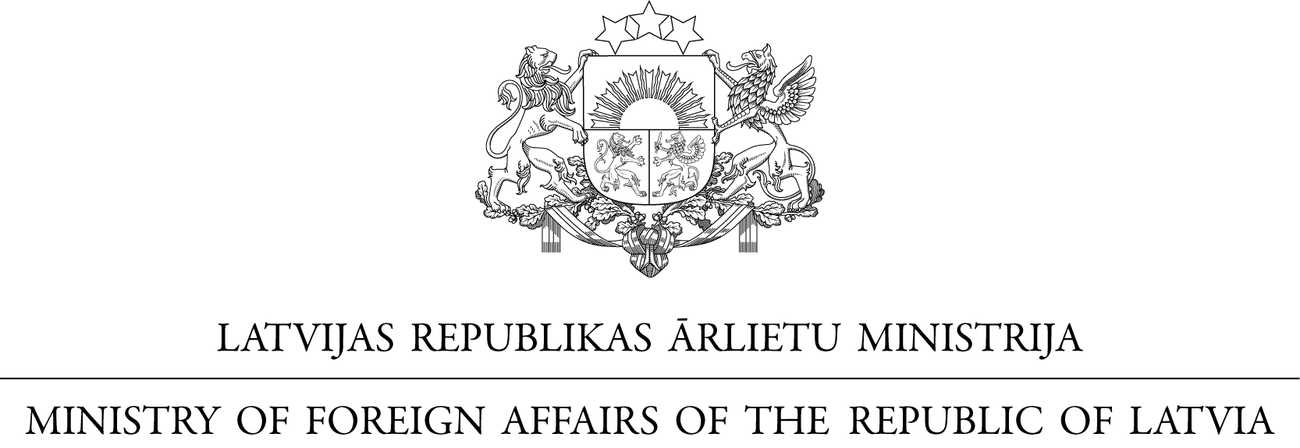

No.

The Ministry of Foreign Affairs of the Republic of Latvia presents its compliments to the Ministry of Foreign Affairs of the Republic of Poland and has the honour to refer to the Ministry’s Note No.DPT.2701.38.2017/1, dated 17 October 2017, concerning the Agreement between the Government of the Republic of Latvia and the Government of the Republic of Poland for the Promotion and Reciprocal Protection of Investments (hereinafter – Agreement), signed in Warsaw on 26 April 1993, and convey the following.

The Ministry has the honour to confirm that the proposal by the Republic of Poland to amend and to terminate the Agreement without application of its Article 13, Paragraph 2 is acceptable to the Government of the Republic of Latvia. The Ministry has the honour to confirm that the Ministry’s Note No. DPT.2701.38.2017/1 of 17 October 2017, and the present Note in reply shall constitute the Agreement between the Government of the Republic of Latvia and the Government of the Republic of Poland on the Amendments to the Agreement between the Government of the Republic of Latvia and the Government of the Republic of Poland for the Promotion and Reciprocal Protection of Investments, signed in Warsaw on 23 April 1993, and on the Termination thereof, which shall enter into force three months after the date of receiving later notification confirming completion of requirements of internal laws necessary for the entry into force of this Agreement on the Amendments and on the Termination.

The Ministry of Foreign Affairs of the Republic of Latvia avails itself of this opportunity to renew to the Ministry of Foreign Affairs of the Republic of Poland the assurances of its highest consideration.

Riga, November 2017

To the Ministry of Foreign Affairs of the Republic of Poland

WARSAW

