5.pielikums
Ministru kabineta
2012.gada 8.maija
noteikumiem Nr.321

Valsts nozīmes māla atradne "Apriķi"

I. Valsts nozīmes māla atradnes "Apriķi" shēma

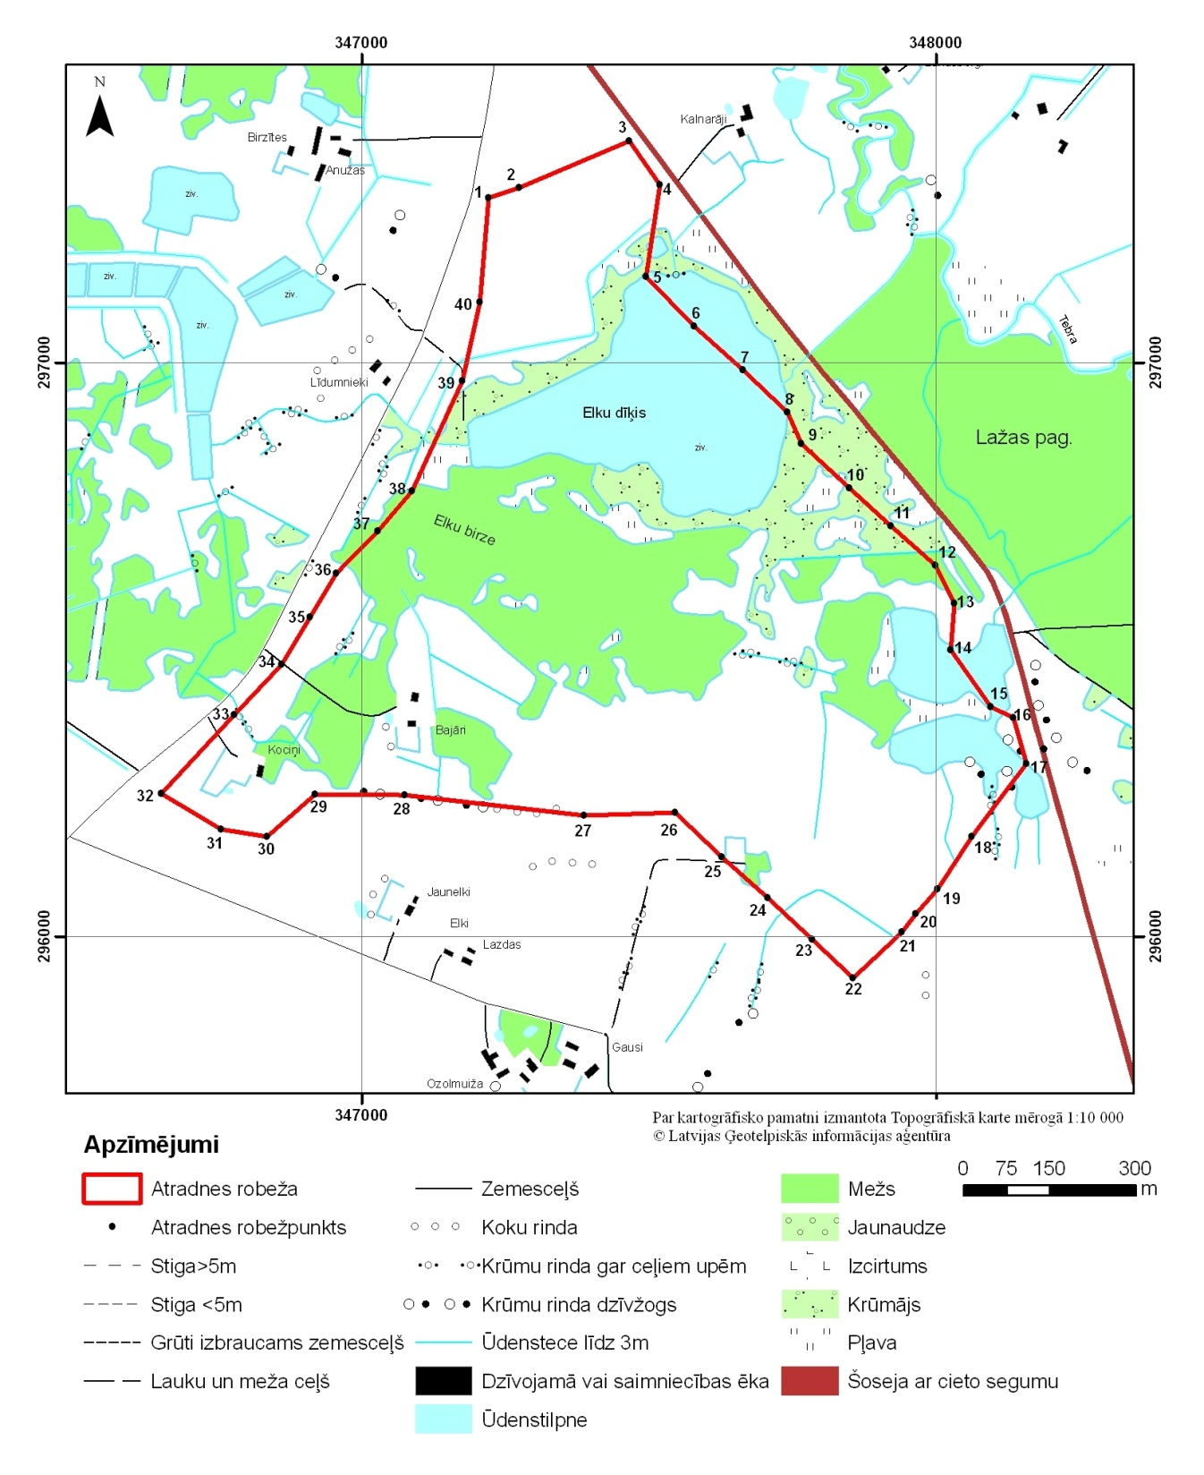

II. Valsts nozīmes māla atradnes "Apriķi" robežpunktu koordinātas (Latvijas ģeodēzisko koordinātu sistēmā LKS-92)

Nr.  p.k. | Robežpunkts | X koordināta | Y koordināta
1. | 1 | 297287,42 | 347220,74
2. | 2 | 297304,51 | 347274,31
3. | 3 | 297386,59 | 347465,82
4. | 4 | 297310,21 | 347518,83
5. | 5 | 297149,48 | 347494,89
6. | 6 | 297063,34 | 347578,90
7. | 7 | 296987,62 | 347663,41
8. | 8 | 296913,82 | 347741,30
9. | 9 | 296858,88 | 347765,21
10. | 10 | 296781,12 | 347849,05
11. | 11 | 296715,22 | 347922,08
12. | 12 | 296647,06 | 347998,58
13. | 13 | 296581,27 | 348032,04
14. | 14 | 296499,04 | 348025,81
15. | 15 | 296399,96 | 348095,74
16. | 16 | 296381,36 | 348134,98
17. | 17 | 296301,39 | 348157,95
18. | 18 | 296174,64 | 348062,67
19. | 19 | 296082,76 | 348003,12
20. | 20 | 296039,27 | 347964,83
21. | 21 | 296008,10 | 347940,78
22. | 22 | 295927,37 | 347855,67
23. | 23 | 295995,71 | 347784,77
24. | 24 | 296067,77 | 347707,45
25. | 25 | 296138,13 | 347626,41
26. | 26 | 296215,61 | 347545,37
27. | 27 | 296210,94 | 347386,65
28. | 28 | 296247,23 | 347073,87
29. | 29 | 296247,67 | 346917,51
30. | 30 | 296174,64 | 346834,69
31. | 31 | 296187,11 | 346753,65
32. | 32 | 296248,56 | 346650,34
33. | 33 | 296385,71 | 346776,80
34. | 34 | 296473,87 | 346859,63
35. | 35 | 296556,70 | 346908,61
36. | 36 | 296632,40 | 346954,92
37. | 37 | 296706,31 | 347027,05
38. | 38 | 296775,78 | 347086,72
39. | 39 | 296968,14 | 347174,00
40. | 40 | 297105,29 | 347205,17

Vides aizsardzības un
reģionālās attīstības ministrs E.Sprūdžs

