1.pielikums
Ministru kabineta
2014.gada 4. februāra
rīkojumam Nr.53

Akvakultūras darbībai nepieciešamo iekārtu ierīkošanai un ekspluatācijai paredzētie atļaujas laukumi

I. Atļaujas laukumu koordinātas* Latvijas Republikas teritoriālajā jūrā

Nr.  p.k. | WGS84 |  | LKS92 TM |  | Platība, m² | Platība, NM^{2 **} | Attālums līdz krastam, NM***
 | B | L | X | Y
1. | 57°14.52'N | 24°02.33'E | 344325.423 | 502343.709 | 13702670 | 4,00 | 7,3
 | 57°14.52'N | 24°06.02'E | 344329.214 | 506055.418
 | 57°12.52'N | 24°06.02'E | 340618.571 | 506060.882
 | 57°12.52'N | 24°02.33'E | 340614.778 | 502345.823
2. | 57°05.80'N | 23°36.71'E | 328213.376 | 476480.946 | 13722961 | 4,00 | 6,4
 | 57°07.57'N | 23°33.68'E | 331515.734 | 473442.282
 | 57°08.72'N | 23°35.90'E | 333635.506 | 475694.880
 | 57°06.95'N | 23°38.90'E | 330334.952 | 478703.468
3. | 57°22.70'N | 23°14.40'E | 359756.778 | 454301.692 | 13725977 | 4,00 | 4,9
 | 57°22.70'N | 23°18.11'E | 359716.929 | 458019.610
 | 57°20.70'N | 23°19.61'E | 355991.157 | 459486.104
 | 57°20.70'N | 23°15.90'E | 356029.660 | 455764.805
4. | 57°32.15'N | 22°57.40'E | 377514.826 | 437534.881 | 13718646 | 4,00 | 4,9
 | 57°32.73'N | 23°01.24'E | 378533.833 | 441381.965
 | 57°30.50'N | 23°01.24'E | 374396.519 | 441322.299
 | 57°30.50'N | 22°57.40'E | 374453.613 | 437487.851
5. | 57°19.00'N | 21°12.90'E | 356068.480 | 332284.270 | 13712031 | 4,00 | 5,6
 | 57°19.00'N | 21°16.60'E | 355918.164 | 335996.725
 | 57°17.00'N | 21°16.60'E | 352209.219 | 335848.263
 | 57°17.00'N | 21°12.90'E | 352359.615 | 332132.444
6. | 56°53.94'N | 20°51.32'E | 310547.514 | 308489.756 | 13679157 | 3,99 | 6,7
 | 56°52.63'N | 20°54.11'E | 307989.290 | 311210.366
 | 56°51.18'N | 20°53.83'E | 305313.711 | 310804.073
 | 56°51.18'N | 20°50.73'E | 305457.831 | 307654.958
 | 56°53.94'N | 20°50.73'E | 310575.107 | 307891.150
7. | 56°10.00'N | 20°40.00'E | 229632.269 | 293047.199 | 12489716 | 3,64 | 10,3
 | 56°10.00'N | 20°41.67'E | 229549.050 | 294774.523
 | 56°12.39'N | 20°41.22'E | 234002.060 | 294522.171
 | 56°15.50'N | 20°40.77'E | 239789.878 | 294335.279
 | 56°15.50'N | 20°40.00'E | 239828.285 | 293540.752
8. | 56°04.96'N | 20°41.46'E | 220216.223 | 294108.809 | 13728754 | 4,00 | 11,1
 | 56°07.23'N | 20°39.91'E | 224501.731 | 292705.631
 | 56°07.77'N | 20°42.00'E | 225398.643 | 294917.892
 | 56°05.78'N | 20°44.74'E | 221574.593 | 297580.598

Piezīmes.
1. * Koordinātas ir norādītas 1984.gada pasaules ģeodēziskajā koordinātu sistēmā WGS84 (World Geodetic System 1984), izmantojot ģeodēziskās (eliptiskās) koordinātas, un Merkatora transversālās projekcijas plaknē (LKS92 TM), izmantojot metriskās koordinātas.
2. ** NM² – jūras kvadrātjūdzes.
3. *** NM – jūras jūdzes.

II. Atļaujas laukumu attēlojums kartē
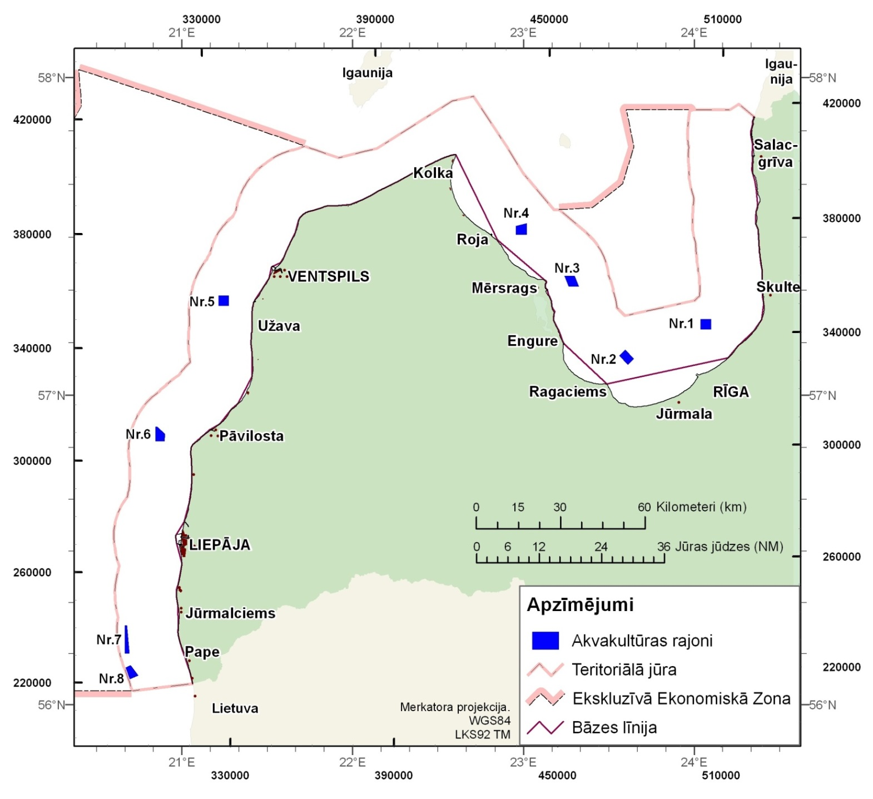

Zemkopības ministrs Jānis Dūklavs

